 | Banking  Credit Card Onboarding  Technical Design Document  1.0
 | Prepared By / Last Updated By | Reviewed By | Approved By
Name | Person 1 | Person 2 | Person 3
Role | Team Member | Team Member | Scrum Master
Signature
Date

Table of Contents

1.0 Introduction 3
1.1 Purpose of this document 3
1.2 Scope 3
1.3 Intended Audience 3
1.4 Definition & Acronyms 3
2.0 Conventions and Standards Followed 4
3.0 Assumptions, Dependencies and Risks 4
3.1 Assumptions: 4
3.2 Dependencies: 4
4.0 Schematic Diagram 4
5.0 Use Case Realization 5
5.1.1 User Registration 5
a. Functional Requirement 6
b. UI Validations 6
c. UI Controls 7
d. UI Methods Definition 8
e. UI Design 9
6.0 Database Design 9
6.1 Data Model 9
6.2 Tables Structure 10
7.0 Change Log 11

Introduction

Purpose of this document
This document is aimed at:

- Providing the necessary inputs to the detailed requirements gathering phase and further on for the SDLC processes.
- This document also serves to establish the traceability between the Business Objectives and the requirements identified in the proposed solution and how they satisfy the stated objectives.
- Provide expectation traceability in terms of the requirements and the user expectation
- Serves as a formal template for documenting the Business Requirements which also includes statutory and regulatory requirements.

The purpose of this document is to systematically capture requirements for the project and the system to be developed. Functional requirements are captured in this document. It also serves as the input for the project scoping.

Scope
This sub-section shall state the scope of this detailed design document
• Create and maintain user information.
• Create and maintain application status.

Intended Audience
The intended audience for this document are
- All members of the project.
- Delivery assurance/excellence group

Definition & Acronyms
Acronyms | Definitions
CCO | Credit Card Onboarding

Conventions and Standards Followed
The modules under scope needs to adhere to the coding standards and guidelines


Assumptions, Dependencies and Risks

Assumptions:
- Once the application is built the user will be able to apply for credit card and check the status of the application from the system.
- There will be no concurrent users for the application. The Credit card information will be maintained by the System.
- Any changes to the design mentioned in the BRD would be taken as a Change Request

Dependencies:
- Availability of database design characteristics & access shall be defined by the Resource availability throughout each of the sprint

Schematic Diagram
A schematic, or schematic diagram, is a representation of the elements of a system using abstract, graphic symbols rather than realistic pictures. It gives an overview of overall system
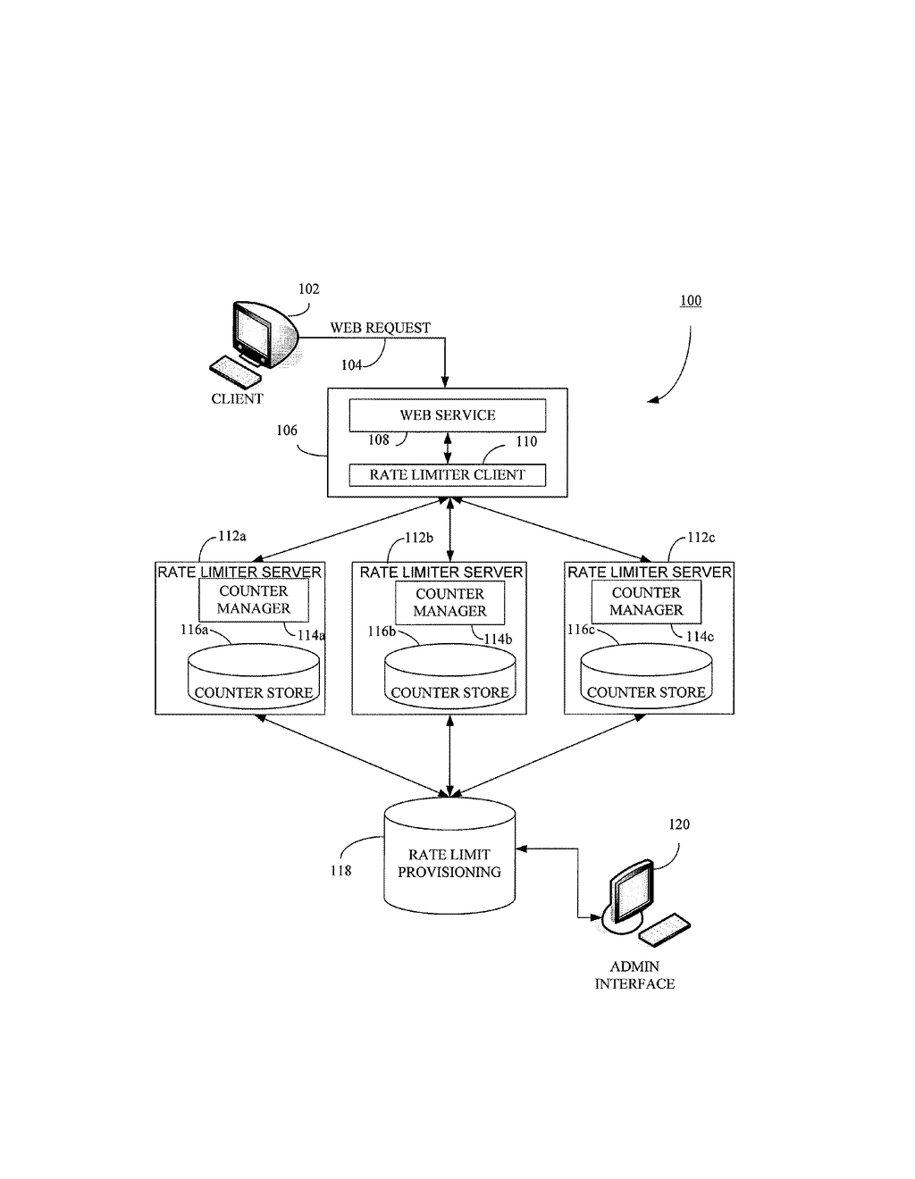
The above pic is only an example and not representational of the Credit card onboarding project

Use Case Realization

User Registration

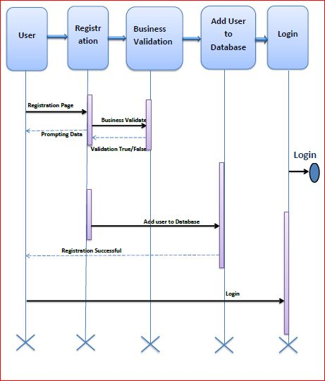

Functional Requirement
. Home Page allows the user to apply for credit card by the registration process which checks whether the user is a valid user or not and check the status of the application if already applied.

UI Validations
- User Id and Password fields are mandatory.
- Invalid User Id and / or password should not allow the user to get into the system

UI Controls
# | UI Component | Type | Name | Details
1 | User Id | Label | label_For_User_Id
2 | User | Text field | Textfield_user | To enter user id
3 | password | Label | Label_for_password
4 | password | Text field | Textfield_password | To enter password

UI Methods Definition
Method Name | Parameter | Details
SignButton_Click | object sender, EventArgs e | Allows the user to login into the portal and register the patient.
ResetButton_Click | object sender, EventArgs e | Clears the details entered by the user.
HomeButton_Click | object sender, EventArgs e | Loads the Homepage after registration is done successfully.
RegisterButton_Click | object sender, EventArgs e | Allows the user to insert the User personal details
ResetButton_Click | object sender, EventArgs e | Resets all fields given by user.
Page_Load | None | None
BMICalculator_Button_Click | object sender, EventArgs e | Allows the user to calculate the BMI of Patient
GlucometerButton_Click | object sender, EventArgs e | Allows the user to calculate the Blood Glucose Level of Patient
BloodCountButton_Click | object sender, EventArgs e | Allows the user to calculate the Blood Count Details of Patient
BMI_SubmitButton_Click | object sender, EventArgs e | To store the details to the database
Glucometer_SubmitButton_Click | object sender, EventArgs e | To store the details to the database
BloodCount_Submit_Button_Click | object sender, EventArgs e | Stores all the details in the database

UI Design
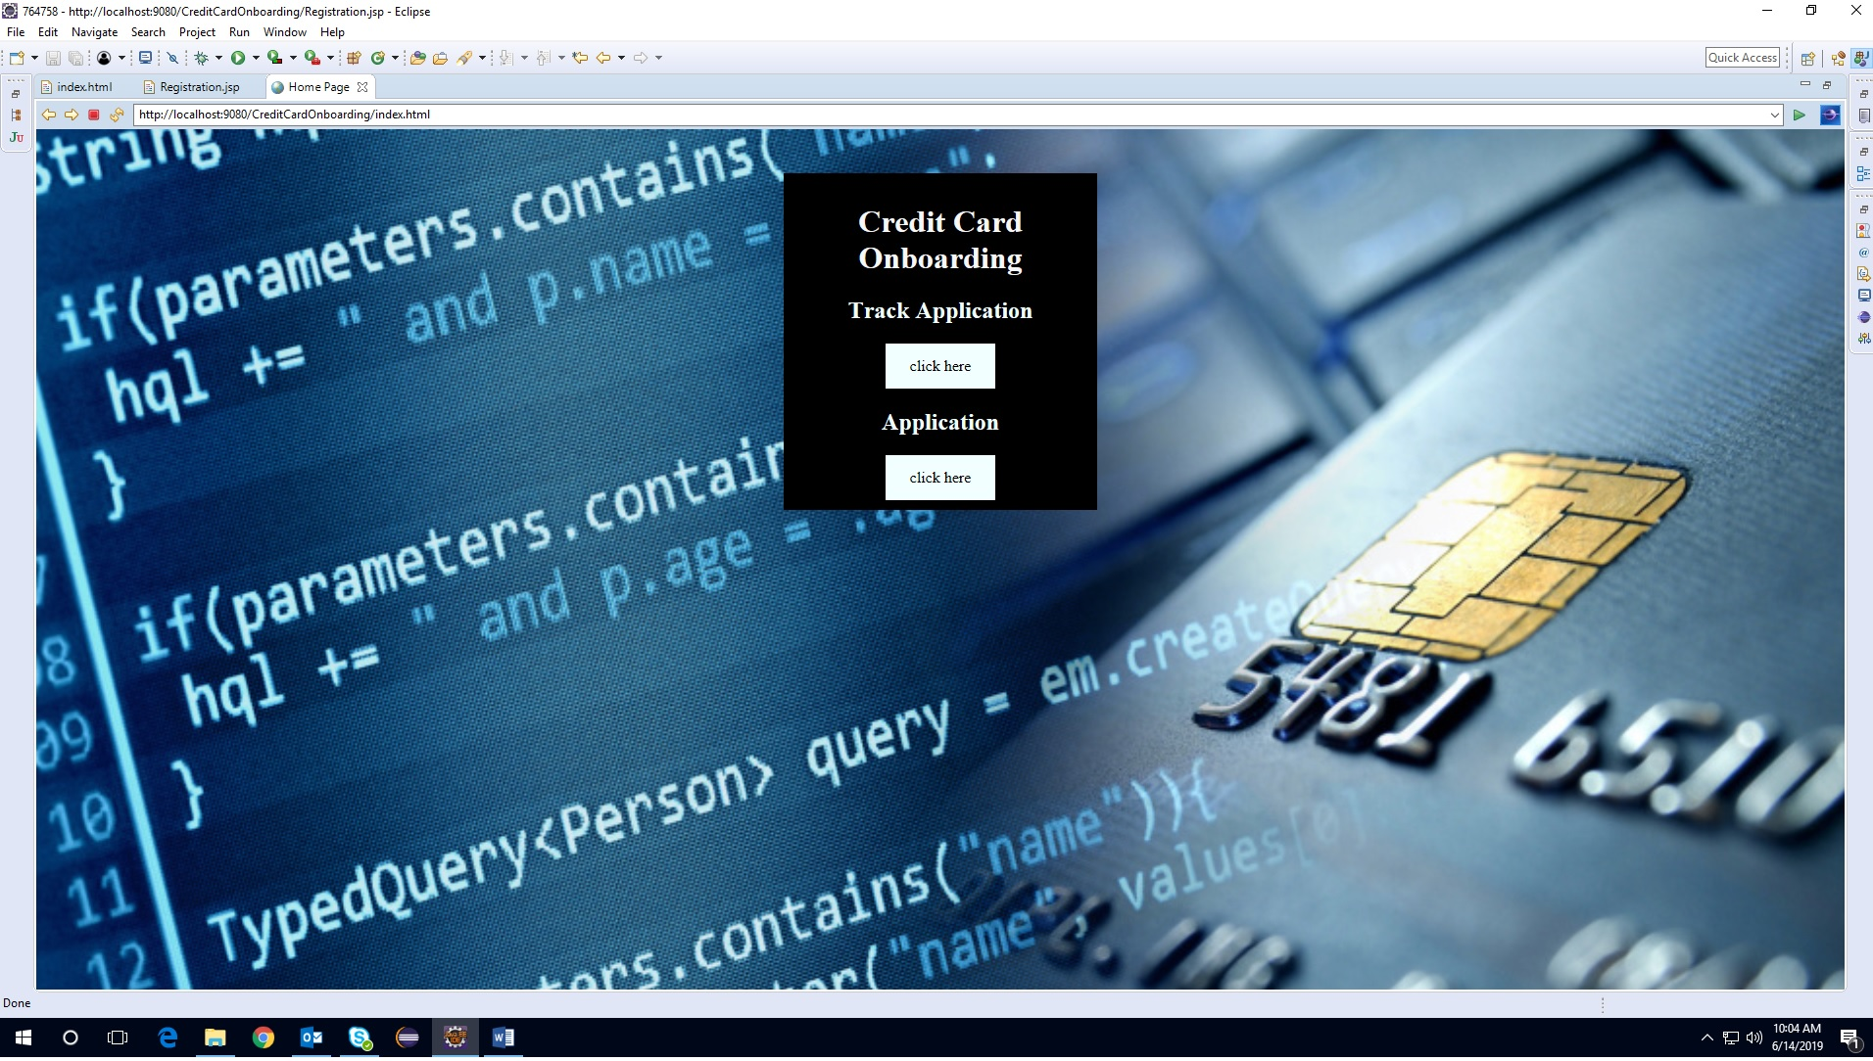

Database Design

Data Model

The following is a schematic view of the database design
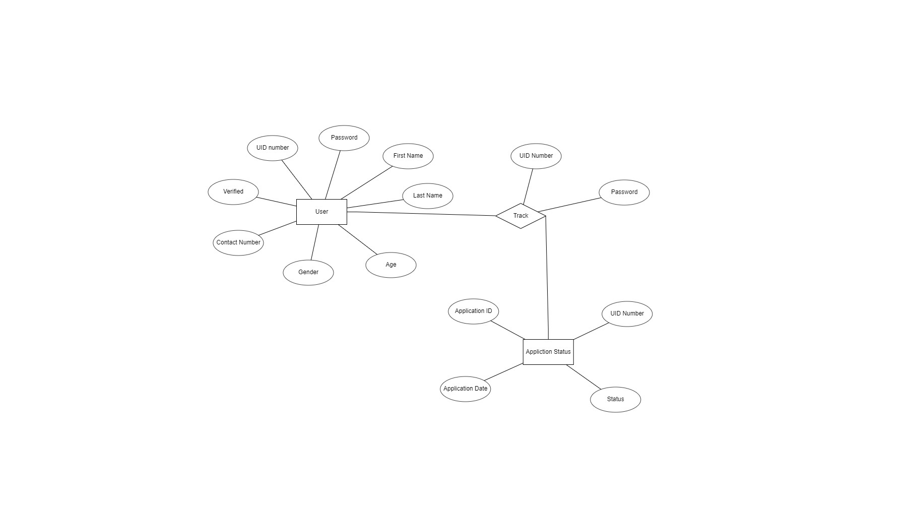

Tables Structure
User Registration:
Column Name | Data Type | Length | Nulls
First Name | nvarchar | 50 | N
Last Name | nvarchar | 50 | N
Age | int | 2 | N
Gender | varchar | 10 | N
Contact Number | varchar | 10 | N
Verified | nvarchar | 1 | N
UID Number | int | 20 | N
Password | nvarchar | 15 | N

Track Application:
Column Name | Data Type | Length | Nulls
UID Number | int | 20 | N
Application ID | int | 20 | N
Application Date | nvarchar | 10 | N
Status | nvarchar | 10 | N

Change Log
Please note that this table needs to be maintained even if a Configuration Management tool is used.
Version Number | Changes made
V1.0 | <First version>
V1.1 | <If the change details are not explicitly documented in the table below, reference should be provided here>
V1.1 | Page no | Changed by | Effective date | Changes effected
V1.2 | <If the change details are not explicitly documented in the table below, reference should be provided here>
V1.2 | Page no | Changed by | Effective date | Changes effected

